1. 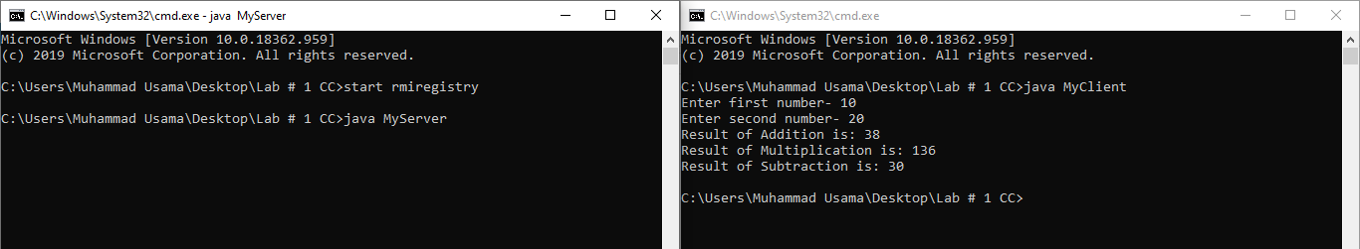Create RMI program in which server performs basic arithmetic operations

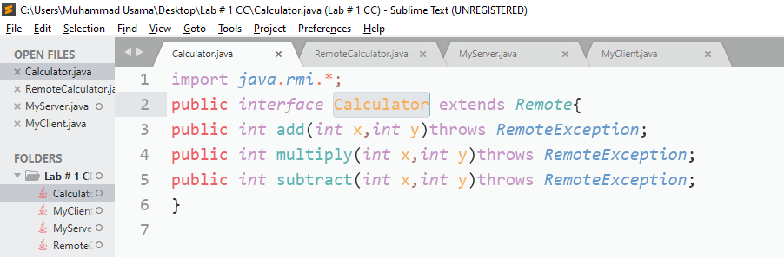Note I forgot to pass parameters to add subtract and delete methods (instead use static values) that’s why results are contradicting

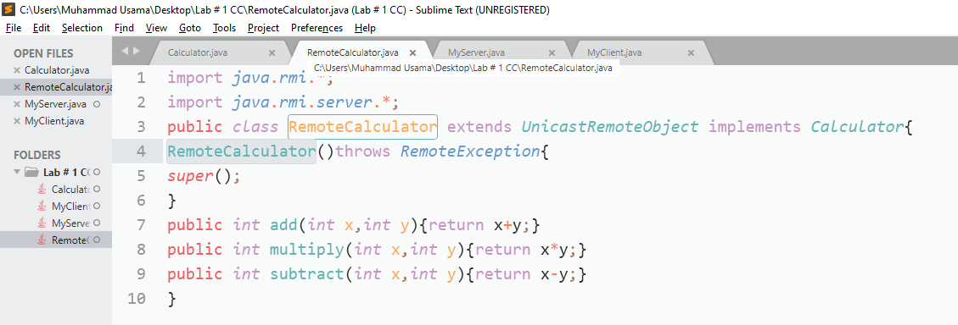

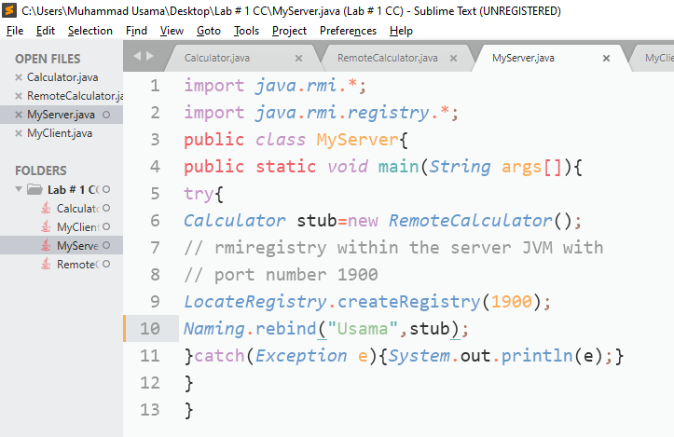

Note : As you can see here stub.add(34,4) instead I should use stub.add(num1,num2)

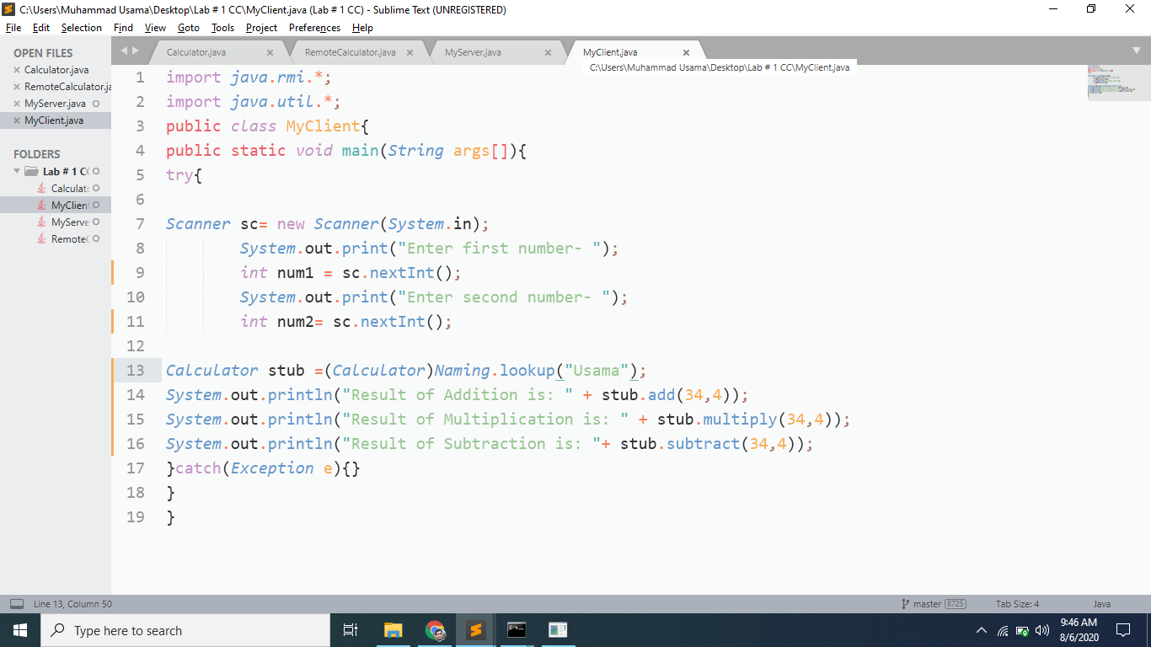

2. Create RMI program in which server sorts the numbers in ascending order.

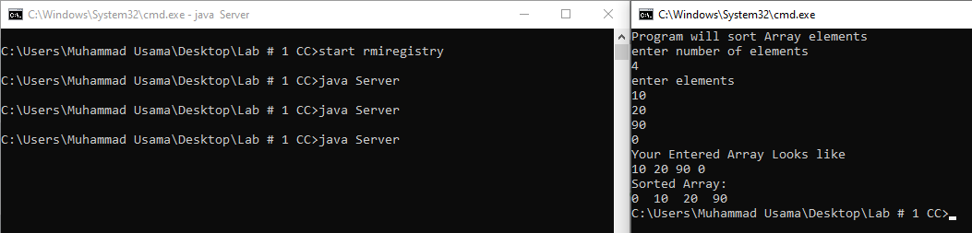

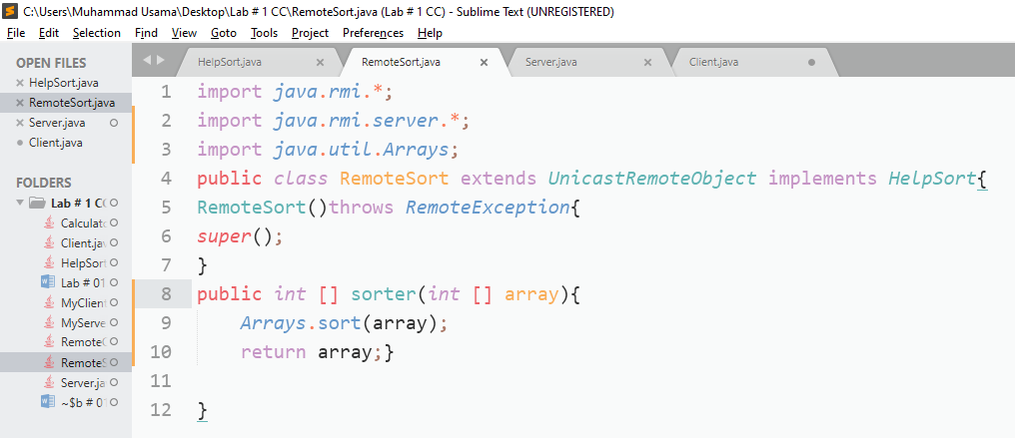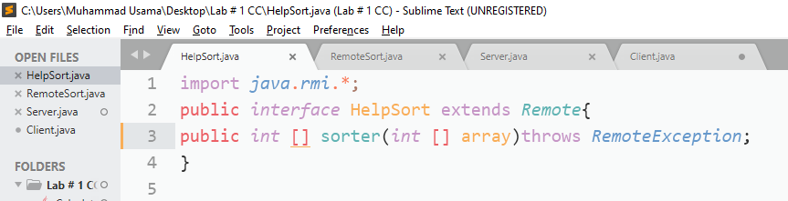

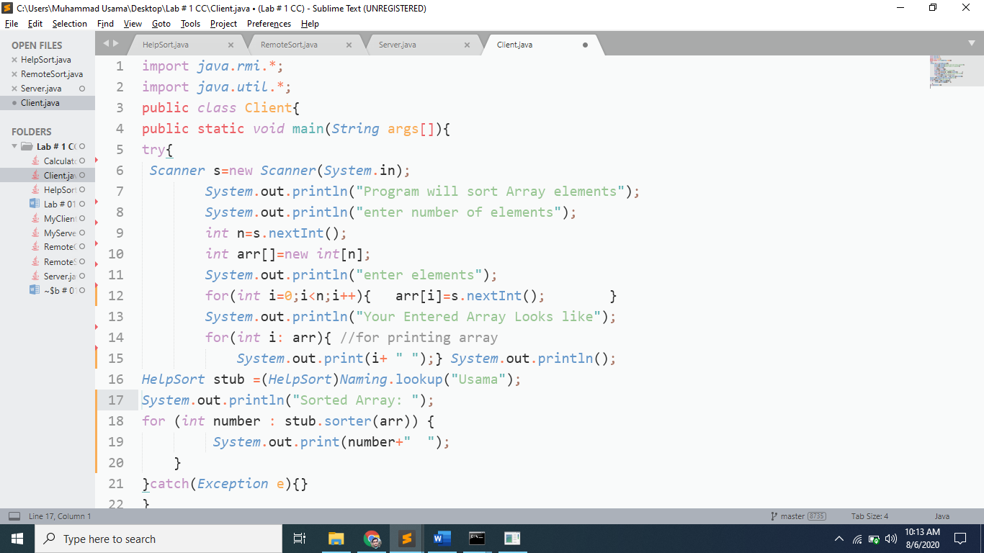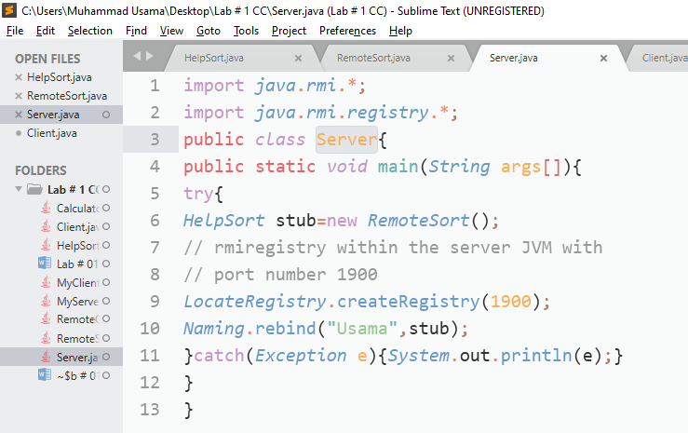

1. (Optional Task) Write an RMI program to implement the Map/Reduce concept of Hadoop on the server program. In other words the client program asks user to provide multiple sentences and send to server, server sends back the word counts.

